State Space

Initial state:

- Start X-Location, Start Y-Location

Actions and transition Models (operators):

- Move Up (x = x, y = y - 1)

- Move Right (x = x + 1, y = y)

- Move Left (x = x - 1, y = y)

- Move Down (x = x, y = y + 1)

Goal state test:

- X-Location = Goal X-Location

- Y-Location = Goal Y-Location

Path cost function:

- 1 cost per action executed

Example:

- 4 x 4 Maze

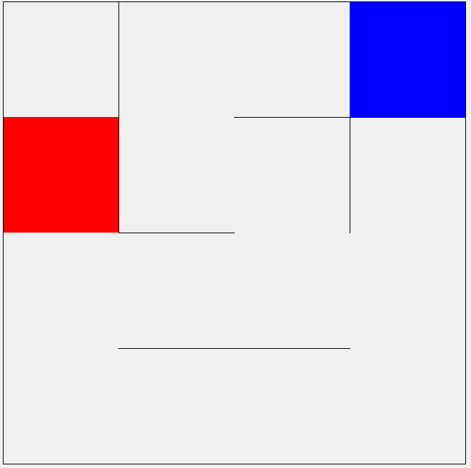

Initial State:

- 3,0

Action:

- Move Up (x = x, y = y - 1)

- Move Right (x = x + 1, y = y)

- Move Left (x = x - 1, y = y)

- Move Down (x = x, y = y + 1)

Goal:

- 0,1

Cost:

- 1 cost per action executed